How To Install MariaDB 10.6 on Debian 11/10/9
By
Lorna Chepkoech
-
10122
0
MariaDB is a popular open source relational databases, developed by MySQL developers. Unlike MySQL, MariaDB was meant to be totally free for use. Its development puts a lot of considerations on performance and stability. MariaDB is also mostly preferred for being robust and scalable with new storage engines. MariaDB 10.6 also comes with a number of improvements from version 10.5 and some additional features. mariaDB has different tools and plugins that make it widely applicable. It is the default database in most Linux distributions.
This guide presents a step-by-step installation of MariaDB 10.6 on Debian 11/10/9 from MariaDB APT repository.
MariaDB 10.6 is the current stable version of MariaDB and comes with a number of improvements and new features as discussed below:

New Features of MariaDB 10.6
- Ignored Indexes – These are indexes that are visible and maintained but not used by the optimizer
- sys schema supported– This is a “system” database containing views and procedures for investigating performance problems.
- SKIP LOCKED – Locked tables are skipped from being updated or selected.
- JSON_TABLE() – can create a JSON table that can be used as a subquery from a JSON document.
- OFFSET…FETCH…[WITH TIES] – WITH TIES is an optional clause that adds extra functionality. Example as used
- Oracle compatibility – There are ongoing works in making MariaDB compatible with OracleDB with some Oracle Syntaxes and functions already added.

Improvements in MariaDB 10.6
Some of the improvements on MariaDB 10.6 from its predecessors include:
- Atomic DDL – CREATE, ALTER, DROP and RENAME are atomic and crash safe. If MariaDB server crashes while processing any of these operations, the change will either e done completely or not done at all.
- InnoDB improvements – First insert to an empty table is faster. Also writes to temporary tables are avoided.Faster implicit and explicit temporary tables.
- Improvements in Galera. Ability to enable encrypted connections between two nodes without downtime. Also added flags to specify if galera controversial compatible features should be enabled.
- Clean up to remove unsupported features such as TukoDB Engine, Cassandra Engine, some InnoDB variables and some innodb_checksum_algorithm.

Installing MariaDB 10.6 on Debian 11/10/9
Follow the next steps to install MariaDB 10.6 on your latest Debian Servers

Step 1: System Upgrade
It is always recommend to have the latest system packages before installation to avoid dependency issues. Run the below commands:
sudo apt update
sudo apt upgrade
sudo reboot

Step 2: Install required Packages
Next, install necessary packages as below:
sudo apt-get install curl software-properties-common dirmngr

Step 3: Add MariaDB Signing Key and APT Repository
Run the below commands respectively to import MariaDB signing key and add MariaDB APT repository
For Debian 11 (Bullseye):
curl -LsS -O https://downloads.mariadb.com/MariaDB/mariadb_repo_setup
sudo bash mariadb_repo_setup --os-type=debian --os-version=buster --mariadb-server-version=10.6
wget http://ftp.us.debian.org/debian/pool/main/r/readline5/libreadline5_5.2+dfsg-3+b13_amd64.deb
sudo dpkg -i libreadline5_5.2+dfsg-3+b13_amd64.deb
For Debian 10 (Buster):
curl -LsS -O https://downloads.mariadb.com/MariaDB/mariadb_repo_setup
sudo bash mariadb_repo_setup --mariadb-server-version=10.6
For Debian 9 “Stretch”
curl -LsS -O https://downloads.mariadb.com/MariaDB/mariadb_repo_setup
sudo bash mariadb_repo_setup --mariadb-server-version=10.6

Step 4: Install MariaDB on Debian 11/10/9
Next, update packages and install MariaDB server
sudo apt-get update
sudo apt-get install mariadb-server mariadb-client
Proceed to install MariaDB packages and all its dependencies:
....
The following NEW packages will be installed:
galera-4 gawk libcgi-fast-perl libcgi-pm-perl libclone-perl libdaxctl1 libdbd-mariadb-perl libdbi-perl libencode-locale-perl libfcgi-bin libfcgi-perl
libfcgi0ldbl libgdbm-compat4 libhtml-parser-perl libhtml-tagset-perl libhtml-template-perl libhttp-date-perl libhttp-message-perl libio-html-perl
liblwp-mediatypes-perl libmariadb3 libmpfr6 libndctl6 libperl5.32 libpmem1 libsigsegv2 libterm-readkey-perl libtimedate-perl liburi-perl lsof mariadb-client
mariadb-client-10.6 mariadb-client-core-10.6 mariadb-common mariadb-server mariadb-server-10.6 mariadb-server-core-10.6 mysql-common perl perl-modules-5.32
rsync
0 upgraded, 41 newly installed, 0 to remove and 0 not upgraded.
Need to get 37.5 MB of archives.
After this operation, 265 MB of additional disk space will be used.
Do you want to continue? [Y/n] y

Step 5: Start and Enable MariaDB
Now run the following commands to start MariaDB and enable it to automatically start on system reboot
sudo systemctl start mariadb
sudo systemctl enable mariadb
Confirm that MariaDB is running
$ sudo systemctl status mariadb
● mariadb.service - MariaDB 10.6.3 database server
Loaded: loaded (/lib/systemd/system/mariadb.service; enabled; vendor pres>
Drop-In: /etc/systemd/system/mariadb.service.d
└─migrated-from-my.cnf-settings.conf
Active: active (running) since Wed 2021-07-28 23:03:14 EAT; 8min ago
Docs: man:mariadbd(8)
https://mariadb.com/kb/en/library/systemd/

Step 6: Secure MariaDB Installation
Once MariaDB is successfully installed, proceed to secure it as below:
$ sudo mysql_secure_installation

NOTE: RUNNING ALL PARTS OF THIS SCRIPT IS RECOMMENDED FOR ALL MariaDB
SERVERS IN PRODUCTION USE! PLEASE READ EACH STEP CAREFULLY!

In order to log into MariaDB to secure it, we'll need the current
password for the root user. If you've just installed MariaDB, and
haven't set the root password yet, you should just press enter here.

Enter current password for root (enter for none):
OK, successfully used password, moving on...

Setting the root password or using the unix_socket ensures that nobody
can log into the MariaDB root user without the proper authorisation.

You already have your root account protected, so you can safely answer 'n'.

Switch to unix_socket authentication [Y/n] Y
Enabled successfully!
Reloading privilege tables..
... Success!

You already have your root account protected, so you can safely answer 'n'.

Change the root password? [Y/n] Y
New password:
Re-enter new password:
Password updated successfully!
Reloading privilege tables..
... Success!

By default, a MariaDB installation has an anonymous user, allowing anyone
to log into MariaDB without having to have a user account created for
them. This is intended only for testing, and to make the installation
go a bit smoother. You should remove them before moving into a
production environment.

Remove anonymous users? [Y/n] Y
... Success!

Normally, root should only be allowed to connect from 'localhost'. This
ensures that someone cannot guess at the root password from the network.

Disallow root login remotely? [Y/n] Y
... Success!

By default, MariaDB comes with a database named 'test' that anyone can
access. This is also intended only for testing, and should be removed
before moving into a production environment.

Remove test database and access to it? [Y/n] Y
- Dropping test database...
... Success!
- Removing privileges on test database...
... Success!

Reloading the privilege tables will ensure that all changes made so far
will take effect immediately.

Reload privilege tables now? [Y/n] Y
... Success!

Cleaning up...

All done! If you've completed all of the above steps, your MariaDB
installation should now be secure.

Thanks for using MariaDB!

Step 7: Check MariaDB Version
To check MariaDB version, we need to login to MariaDB as below. Use -p if you have set the root password.
$ mysql -u root -p
Enter password:
Welcome to the MariaDB monitor. Commands end with ; or \g.
Your MariaDB connection id is 32
Server version: 10.6.3-MariaDB-1:10.6.3+maria~buster mariadb.org binary distribution

Copyright (c) 2000, 2018, Oracle, MariaDB Corporation Ab and others.

Type 'help;' or '\h' for help. Type '\c' to clear the current input statement.

MariaDB [(none)]>
Then run the following MySQL command to check MariaDB version
MariaDB [(none)]> SELECT VERSION();
+----------------------------------------+
| VERSION() |
+----------------------------------------+
| 10.6.4-MariaDB-1:10.6.4+maria~bullseye |
+----------------------------------------+
1 row in set (0.000 sec)

MariaDB [(none)]>

Step 8: MariaDB Basic Commands
To get started with basic commands, we can check to create a database, users and tables.

MariaDB Create Database
To create a database in MariaDB, login as shown above and run the below command.
#Create a new database
CREATE DATABASE testdb;
Query OK, 1 row affected (0.000 sec)

#If the database with the same exists
CREATE DATABASE testdb;
ERROR 1007 (HY000): Can't create database 'testdb'; database exists

#Create a database if already exits
CREATE OR REPLACE DATABASE testdb;
Query OK, 2 rows affected (0.009 sec)

#First check if a database exists
CREATE DATABASE IF NOT EXISTS testdb;
Query OK, 1 row affected, 1 warning (0.000 sec)

# Check Databases MariaDB
SHOW DATABASES;

MariaDB add User and Grant Privileges
To create a user and grant privileges;
#Create user mariadb
CREATE USER 'myuser'@'localhost' IDENTIFIED BY 'mypassword';

#Grant all privileges to the user
GRANT ALL PRIVILEGES ON *.* TO 'myuser'@'localhost' IDENTIFIED BY 'mypassword';

#Grant privileges to a specific database
GRANT ALL PRIVILEGES ON 'DB1'.* TO 'user1'@'localhost';

#Remember to refresh the privileges
FLUSH privileges;

#To check user grants in MariaDB
SHOW GRANTS FOR 'myuser'@'locahost';

Create a Table and Add Data MariaDB
Once you have created a database, you can create table and add data into it
CREATE TABLE employees (id INT, name VARCHAR(20), email VARCHAR(20));
INSERT INTO employees (id,name,email) VALUES(01,"lorna","lorna@example.com")

MariaDB Clean up
To completely remove MariaDB, run the following commands.
sudo apt purge mariadb-server
sudo rm -rf /var/lib/mysql/
That’s it. You have successfully installed MariaDB 10.6 on Debian 11/10/9. It is a simple and straightforward installation. I hope the guide has been helpful.

Udemy Video Courses to Learn MySQL / MariaDB Databases:
- The Ultimate MySQL Bootcamp: Go from SQL Beginner to Expert
- SQL – MySQL for Data Analytics and Business Intelligence
- MySQL, SQL and Stored Procedures from Beginner to Advanced
- SQL for Beginners: Learn SQL using MySQL and Database Design
- The Complete MySQL Developer Course
- MySQL Database Administration: Beginner SQL Database Design
- Learn Database Design with MySQL

https://computingforgeeks.com/how-to-install-mariadb-on-debian-linux/

Install MariaDB 10.5 on Debian 11 / Debian 10
By
Josphat Mutai
-
69242
1
Welcome to today’s guide on how to install MariaDB 10.5 on Debian 11 / Debian 10. MariaDB is a drop-in replacement of MySQL with more features, new storage engines, and better performance. You can read more on MariaDB 10.5 features from the official website.
MariaDB 10.5 is a stable release of MariaDB as of this article update. Follow the steps below to install MariaDB 10.5 on Debian 11 / Debian 10. We will add the official MariaDB apt repository, then install latest packages of MariaDB 10.5 from it on our Debian system.

Step 1: Update system apt index
I recommend you update your system and optionally upgrade installed packages.
sudo apt -y update
sudo apt -y install curl software-properties-common gnupg2
sudo apt -y upgrade
sudo reboot

Step 2: Import MariaDB gpg key and add repository.
We need to import MariaDB gpg key which contains the keys used for signing MariaDB Debian packages. Then add the MariaDB repository to your system:
curl -LsS -O https://downloads.mariadb.com/MariaDB/mariadb_repo_setup
sudo bash mariadb_repo_setup --mariadb-server-version=10.5
Confirm repository configuration is successful:
# [info] Checking for script prerequisites.
# [info] MariaDB Server version mariadb-10.5 is valid
# [info] Repository file successfully written to /etc/apt/sources.list.d/mariadb.list
# [info] Adding trusted package signing keys...
# [info] Running apt-get update...
# [info] Done adding trusted package signing keys

Step 3: Install MariaDB 10.5 on Debian 10 / Debian 11
After addition of the repository, installation of MariaDB 10.5 server and client packages can be done by running the following commands in your terminal.
sudo apt update
sudo apt install mariadb-server mariadb-client
Accept installation when prompted:
eading package lists... Done
Building dependency tree... Done
Reading state information... Done
The following additional packages will be installed:
galera-4 gawk libcgi-fast-perl libcgi-pm-perl libclone-perl libdbd-mariadb-perl libdbi-perl libencode-locale-perl libfcgi-bin libfcgi-perl libfcgi0ldbl libhtml-parser-perl libhtml-tagset-perl
libhtml-template-perl libhttp-date-perl libhttp-message-perl libio-html-perl liblwp-mediatypes-perl libmariadb3 libsigsegv2 libterm-readkey-perl libtimedate-perl liburi-perl lsof
mariadb-client-10.5 mariadb-client-core-10.5 mariadb-common mariadb-server-10.5 mariadb-server-core-10.5 mysql-common rsync
Suggested packages:
gawk-doc libmldbm-perl libnet-daemon-perl libsql-statement-perl libdata-dump-perl libipc-sharedcache-perl libwww-perl mailx mariadb-test netcat-openbsd
The following NEW packages will be installed:
galera-4 gawk libcgi-fast-perl libcgi-pm-perl libclone-perl libdbd-mariadb-perl libdbi-perl libencode-locale-perl libfcgi-bin libfcgi-perl libfcgi0ldbl libhtml-parser-perl libhtml-tagset-perl
libhtml-template-perl libhttp-date-perl libhttp-message-perl libio-html-perl liblwp-mediatypes-perl libmariadb3 libsigsegv2 libterm-readkey-perl libtimedate-perl liburi-perl lsof mariadb-client
mariadb-client-10.5 mariadb-client-core-10.5 mariadb-common mariadb-server mariadb-server-10.5 mariadb-server-core-10.5 mysql-common rsync
0 upgraded, 33 newly installed, 0 to remove and 0 not upgraded.
Need to get 28.8 MB of archives.
After this operation, 215 MB of additional disk space will be used.
Do you want to continue? [Y/n] y

Step 4: Secure MariaDB server
Now run the secure script to set root password, remove test database and disable remote root user login.
$ sudo mariadb-secure-installation

NOTE: RUNNING ALL PARTS OF THIS SCRIPT IS RECOMMENDED FOR ALL MariaDB
SERVERS IN PRODUCTION USE! PLEASE READ EACH STEP CAREFULLY!

In order to log into MariaDB to secure it, we'll need the current
password for the root user. If you've just installed MariaDB, and
haven't set the root password yet, you should just press enter here.

Enter current password for root (enter for none):
OK, successfully used password, moving on...

Setting the root password or using the unix_socket ensures that nobody
can log into the MariaDB root user without the proper authorisation.

You already have your root account protected, so you can safely answer 'n'.

Switch to unix_socket authentication [Y/n] n
Enabled successfully!
Reloading privilege tables..
... Success!

You already have your root account protected, so you can safely answer 'n'.

Change the root password? [Y/n] y
New password:
Re-enter new password:
Password updated successfully!
Reloading privilege tables..
... Success!

By default, a MariaDB installation has an anonymous user, allowing anyone
to log into MariaDB without having to have a user account created for
them. This is intended only for testing, and to make the installation
go a bit smoother. You should remove them before moving into a
production environment.

Remove anonymous users? [Y/n] y
... Success!

Normally, root should only be allowed to connect from 'localhost'. This
ensures that someone cannot guess at the root password from the network.

Disallow root login remotely? [Y/n] y
... Success!

By default, MariaDB comes with a database named 'test' that anyone can
access. This is also intended only for testing, and should be removed
before moving into a production environment.

Remove test database and access to it? [Y/n] y
- Dropping test database...
... Success!
- Removing privileges on test database...
... Success!

Reloading the privilege tables will ensure that all changes made so far
will take effect immediately.

Reload privilege tables now? [Y/n] y
... Success!

Cleaning up...

All done! If you've completed all of the above steps, your MariaDB
installation should now be secure.

Thanks for using MariaDB!
You now need to provide username and password to access MySQL console. Without authentication, you’ll get access denied error.
$ mysql -u root
ERROR 1698 (28000): Access denied for user 'root'@'localhost'
Use the -p option to authenticate.
$ mysql -u root -p
Enter password:
Welcome to the MariaDB monitor. Commands end with ; or \g.
Your MariaDB connection id is 31
Server version: 10.5.15-MariaDB-1:10.5.15+maria~bullseye mariadb.org binary distribution

Copyright (c) 2000, 2018, Oracle, MariaDB Corporation Ab and others.

Type 'help;' or '\h' for help. Type '\c' to clear the current input statement.

MariaDB [(none)]> SELECT VERSION();
+------------------------------------------+
| VERSION() |
+------------------------------------------+
| 10.5.15-MariaDB-1:10.5.15+maria~bullseye |
+------------------------------------------+
1 row in set (0.000 sec)

MariaDB [(none)]> EXIT
Bye
https://computingforgeeks.com/how-to-install-mariadb-on-debian/

How To Install MariaDB on Debian 11
By Rahul4 Mins Read
MySQL is a well-liked free database management system and also a prominent component of the LAMP stack. MySQL has been replaced with MariaDB in Debian repositories, which is a decent alternative to MySQL and pretty much performs every operation that MySQL performs.
MySQL is currently not available for Debian 11 Bullseye, so MariaDB is a perfect choice. This article is focusing on how to install MariaDB, an alternative to MySQL on Debian 11.

Install MariaDB on Debian 11
The MariaDB packages are available under the official repositories. You can directly install it without adding an extra repo to your system. For this tutorial, we will install MariaDB on Debian 11 system via default repositories.
Firstly, update the packages list using:
sudo apt update
Now, to install MariaDB, execute the below-mentioned command:
sudo apt install mariadb-server

Configure MariaDB on Debian
To configure MariaDB properly we need to run a security script using the below-mentioned command:
sudo mysql_secure_installation
After running the above command, you will be prompted with various options:
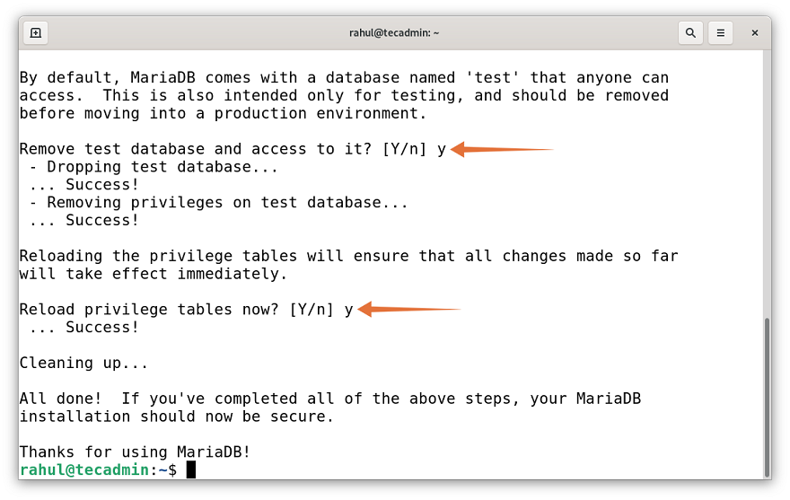
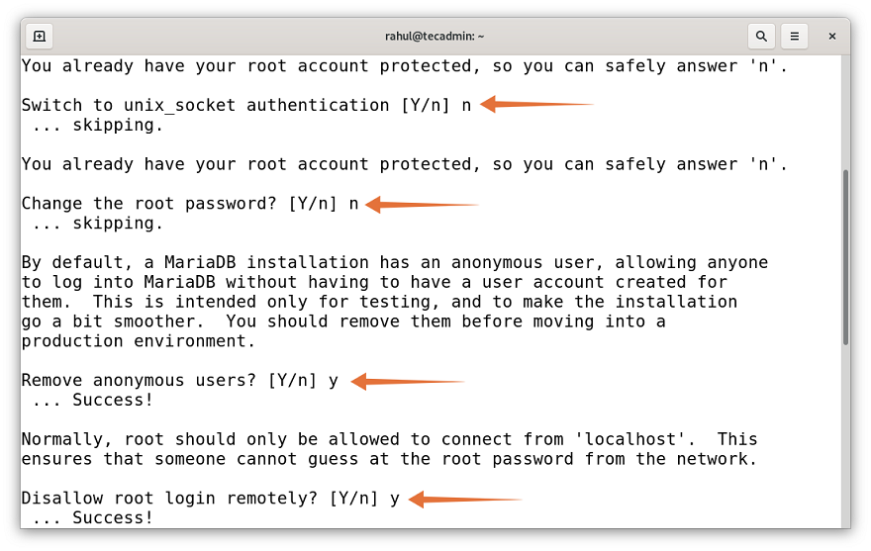
The options are self-explanatory, for the first two options choose “n” and for the next sequence of options press “y” for yes.

Create Privileges User with Authentication
For security purposes, MariaDB uses a unix_socket plugin to authenticate the root user. This may cause complications therefore, it is recommended to set a new user with password-based access. And to create a new user login to MariaDB using:
sudo mysql
Now create a new user with a password in the MariaDB server.
CREATE USER 'admin'@'localhost' IDENTIFIED BY '_pa$$w0rd_';
Make sure to change admin with your username and _pas$$w0rd_ with a new secure password.
Next, grant permissions on all databases to a newly created account. Here the GRANT OPTION allow a user to create other users and assign them permissions.
GRANT ALL ON *.* TO 'admin'@'localhost' WITH GRANT OPTION;
Apply the new changes, execute:
FLUSH PRIVILEGES;
And to quit typing “exit”.
EXIT
The SQL statements are case insensitive, So you can write them in any case.

Connect MariaDB Server
One can manage MariaDB service using the Systemd. To test the status of MariaDB use the following command:
sudo systemctl status mariadb
If for some reasons MariaDB is not running then use the below-mentioned command to start it:
sudo systemctl start mariadb
For one more check you can try to connect to the database using:
sudo mysqladmin version
Output

mysqladmin Ver 9.1 Distrib 10.5.11-MariaDB, for debian-linux-gnu on x86_64
Copyright (c) 2000, 2018, Oracle, MariaDB Corporation Ab and others.

Server version 10.5.11-MariaDB-1
Protocol version 10
Connection Localhost via UNIX socket
UNIX socket /run/mysqld/mysqld.sock
Uptime: 3 hours 45 min 24 sec

Threads: 1 Questions: 497 Slow queries: 0 Opens: 171 Open tables: 28 Queries per second avg: 0.036
Next, connect to the MySQL shell by using the credentials created in the above step.
mysql -u admin -p
The output of the above command asks for the password; use the password you set in the above steps. On successful authentication, you will get the MariaDB shell as below:
Output

Enter password:
Welcome to the MariaDB monitor. Commands end with ; or \g.
Your MariaDB connection id is 60
Server version: 10.5.11-MariaDB-1 Debian 11

Copyright (c) 2000, 2018, Oracle, MariaDB Corporation Ab and others.

Type 'help;' or '\h' for help. Type '\c' to clear the current input statement.

MariaDB [(none)]>

Conclusion
MariaDB is an open-source alternative to MySQL in the latest version of Debian. This write-up is a guide to install MariaDB on Debian 11 Bullseye. We learned how to install and configure MariaDB on Debian 11. We also created a separate user to manage the database with password access. Finally, we also discussed utilities to test the MariaDB status.
https://tecadmin.net/how-to-install-mariadb-on-debian-11/

